Sama seperti pembelian barang yang tidak selamanya menerima barang yang datang sesuai dengan apa yang dipesan proses penjualan barang juga akan mengalami pengembalian barang karena terjadi ketidaksesuaian pesanan atau kerusakan pada barang. Oleh karena itu proses retur penjualan terjadi dan harus dicatat. Dan form retur penjualan yang akan dibuat dapat mencatat retur penjualan barang yang terjadi dari penjualan grosir atau eceran. Untuk membuat form retur penjualan ini yang kita butuhkan adalah:

|  |  |  |
| --- | --- | --- |
| **Object** | **Properties** | **Setting** |
| **Form** | Name | FrmBeliBarang |
|  | BorderStyle | 0-None |
|  | BackColor | &H00FFC0C0& |
|  | StartUpPosition | 2-CenterScreen |
| **Label** | Name | Label1 |
|  | Font | Calibri |
|  | ForeColor | &H8000000D& |
|  | Caption | Form Retur Pembelian |
|  | Name | Label2 |
|  | Font | Calibri |
|  | ForeColor | &H8000000D& |
|  | Caption | No Kwitansi |
|  | Name | Label3 |
|  | Font | Calibri |
|  | ForeColor | &H8000000D& |
|  | Caption | Supplier |
|  | Name | Label4 |
|  | Font | Calibri |
|  | ForeColor | &H8000000D& |
|  | Caption | Tanggal Transaksi |
|  | Name | Label5 |
|  | Font | Calibri |
|  | ForeColor | &H8000000D& |
|  | Caption | Tanggal Kirim |
|  | Name | Label6 |
|  | Font | Calibri |
|  | ForeColor | &H8000000D& |
|  | Caption | Penerima |
|  | Name | Label7 |
|  | Font | Calibri |
|  | ForeColor | &H8000000D& |
|  | Caption | Nama Barang |
|  | Name | Label8 |
|  | Font | Calibri |
|  | ForeColor | &H8000000D& |
|  | Caption | Alasan |
|  | Name | Label9 |
|  | Font | Calibri |
|  | ForeColor | &H8000000D& |
|  | Caption | Jumlah Barang Retur |
|  | Name | Label10 |
|  | Font | Calibri |
|  | ForeColor | &H8000000D& |
|  | Caption | Jenis Penjualan |
| **Textbox** | Name | TxtSupplier |
|  | Appearance | 0-Flat |
|  | Height | 330 |
|  | Name | TxtPenerima |
|  | Appearance | 0-Flat |
|  | Height | 330 |
|  | Name | TxtAlasan |
|  | Appearance | 0-Flat |
|  | Height | 330 |
| **TDBDate** | Name | TxtTgl |
|  | DisplyFormat | dd mmmm yyy |
|  | ButtonVisible | 1-True |
|  | Height | 330 |
|  | Name | TxtTglKirim |
|  | DisplyFormat | dd mmmm yyy |
|  | ButtonVisible | 1-True |
|  | Height | 330 |
| **SSOleDBCombo** | Name | CmbBarang |
|  | Height | 330 |
|  | BackColorOdd | &H00FFC0C0& |
|  | Name | CmbBarang |
|  | Height | 330 |
|  | BackColorOdd | &H00FFC0C0& |
|  | Name | CmbTransaksi |
|  | Height | 330 |
|  | BackColorOdd | &H00FFC0C0& |
|  | Name | CmbBarang |
|  | Height | 330 |
|  | BackColorOdd | &H00FFC0C0& |
| **TDBNumber** | Name | TxtJumlah |
|  | Height | 330 |
|  | appearance | 0-Flat |
|  | DisplayFormat | ###,###,###,##0.00;(###,###,###,##0.00) |
|  | Format | ###,###,###,##0.00 |
| **VBButton** | Name | CmdSave |
|  | ButtonType | 4-Mac |
|  | Caption | &Save |
|  | Name | CmdCancel |
|  | ButtonType | 4-Mac |
|  | Caption | &Cancel |
|  | Name | CmdInput |
|  | ButtonType | 4-Mac |
|  | Caption | &Cari |
|  | Name | vbButton1 |
|  | ButtonType | 3-WindowsXP |
|  | Caption | - |
|  | BackColor | &H00FFC0C0& |
|  | Name | vbButton2 |
|  | ButtonType | 3-WindowsXP |
|  | Caption | X |
|  | BackColor | &H00FFC0C0& |
| **TDBGrid** | Name | Grid |
|  | DeadAreaColor | &H00FFC0C0& |
|  | ColumnFooter | False |
|  | MarqueeStyle | 2-HighlightCell |
| **Adodc** | Name | AdoBarang |
|  | Visible | False |
|  | Name | AdoTransaksi |
|  | Visible | False |
| **OptionButton** | Name | Option1 |
|  | BackColor | &H00FFC0C0& |
|  | Caption | Penjualan Grosir |
|  | Name | Option2 |
|  | BackColor | &H00FFC0C0& |
|  | Caption | Penjualan Eceran |

Tampilan Form Retur Penjualan :

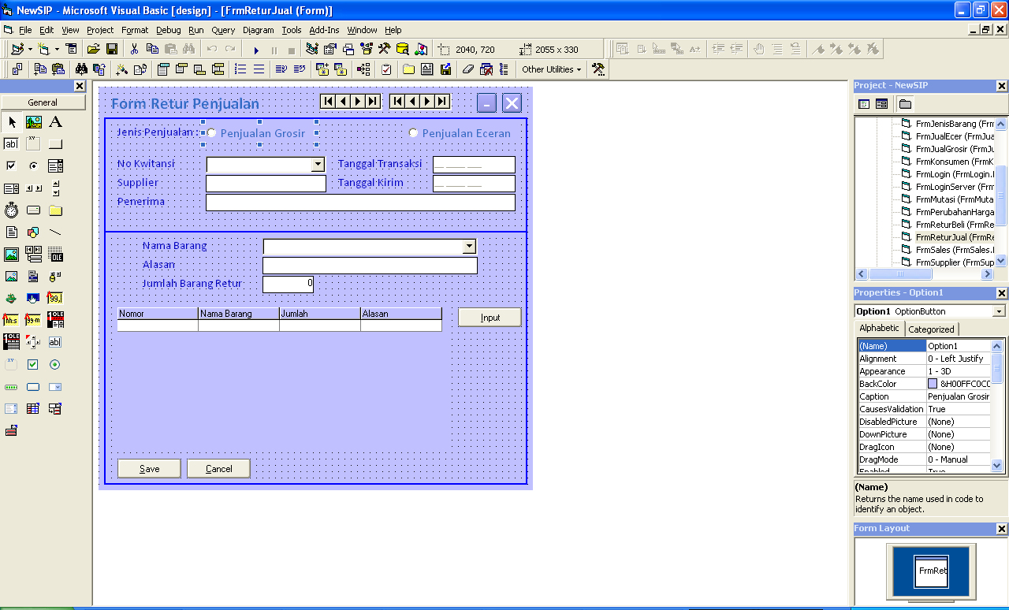

Tampilan saat form retur penjualan dijalankan :

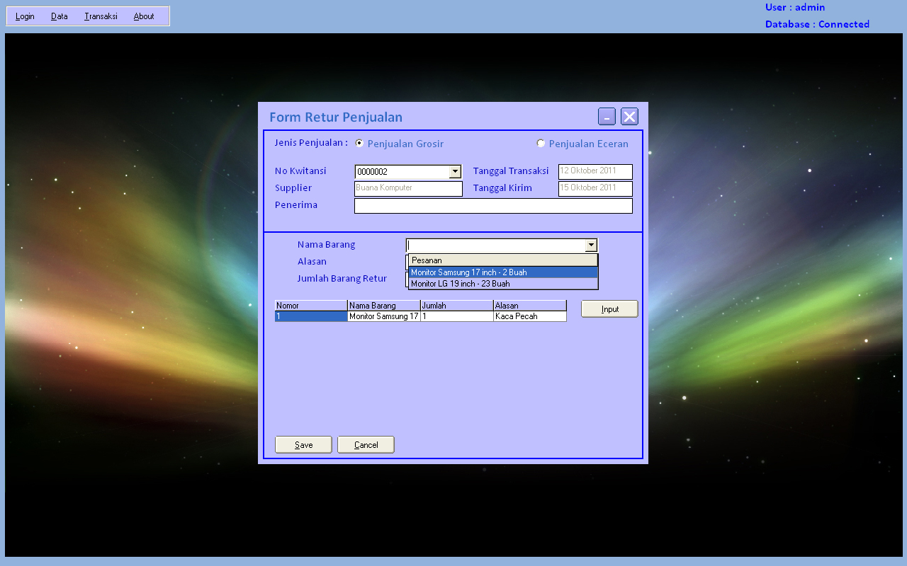

Source code form retur penjualan :

Dim RsTemp6 As New ADODB.Recordset

Dim Keterangan1 As Integer

Dim Penjualan As String

Private Sub CmbBarang_DropDown()

Dim Tran As String

If Option1 Then

AdoBarang.RecordSource = ""

SQL = "SELECT DtlJualGrosir.KodeBarang, Barang.NamaBarang, DtlJualGrosir.Jumlah, " & _

"Barang.NamaBarang + ' - ' + CONVERT(varchar(50), DtlJualGrosir.Jumlah) " & _

"+ ' ' + Barang.Satuan AS Pesanan " & _

"FROM Barang INNER JOIN " & _

"DtlJualGrosir ON Barang.KodeBarang = DtlJualGrosir.KodeBarang " & _

"WHERE (DtlJualGrosir.KodeTransaksi ='" & Trim(CmbTransaksi) & "')"

Set RSFind = DbCon.Execute(SQL)

If RSFind.BOF Then Exit Sub

AdoBarang.RecordSource = SQL

AdoBarang.Refresh

With CmbBarang

.DataSourceList = AdoBarang

.DataFieldList = "Pesanan"

.Columns(0).Visible = False

.Columns(1).Visible = False

.Columns(2).Visible = False

.Columns(3).Width = 4000

End With

End If

End Sub

Private Sub CmbBarang_GotFocus()

If Trim(CmbTransaksi) = "" Or Not CmbTransaksi.IsItemInList Then

MsgBox "Transaksi Belum Dipilih"

CmbTransaksi.SetFocus

Exit Sub

ElseIf Trim(TxtPenerima) = "" Then

MsgBox "Penerima Masih Kosong"

TxtPenerima.SetFocus

Exit Sub

End If

End Sub

Private Sub CmbTransaksi_Click()

TxtSupplier = Trim(CmbTransaksi.Columns(2).Text)

TxtTgl = CmbTransaksi.Columns(1).Value

TxtTglKirim = CmbTransaksi.Columns(3).Value

CmbBarang = ""

CmbBarang.SetFocus

End Sub

Private Sub CmbTransaksi_DropDown()

If Option1 Then

AdoTransaksi.RecordSource = ""

SQL = "SELECT * from JualGrosir"

Set RSFind = DbCon.Execute(SQL)

If RSFind.BOF Then Exit Sub

AdoTransaksi.RecordSource = SQL

AdoTransaksi.Refresh

With CmbTransaksi

.DataSourceList = AdoTransaksi

.DataFieldList = "KodeTransaksi"

.Columns(3).Visible = False

.Columns(2).Visible = False

.Columns(1).Visible = False

.Columns(4).Visible = False

.Columns(3).Width = 4000

End With

ElseIf Option2 Then

AdoTransaksi.RecordSource = ""

SQL = "SELECT * from JualEcer"

Set RSFind = DbCon.Execute(SQL)

If RSFind.BOF Then Exit Sub

AdoTransaksi.RecordSource = SQL

AdoTransaksi.Refresh

With CmbTransaksi

.DataSourceList = AdoTransaksi

.DataFieldList = "KodeTransaksi"

.Columns(3).Visible = False

.Columns(2).Visible = False

.Columns(1).Visible = False

.Columns(4).Visible = False

.Columns(3).Width = 4000

End With

End If

End Sub

Private Sub CmdCancel_Click()

Form_Load

End Sub

Private Sub CmdInput_Click()

If Trim(CmbBarang) = "" Or Not CmbBarang.IsItemInList Then

MsgBox "Barang Belum Ada"

CmbBarang.SetFocus

Exit Sub

ElseIf Trim(TxtAlasan) = "" Then

MsgBox "Alasan Belum Ada"

TxtAlasan.SetFocus

Exit Sub

ElseIf TxtJumlah = 0 Then

MsgBox "Jumlah Belum Ada"

TxtJumlah.SetFocus

Exit Sub

End If

SQL = "Select jumlah from dtlbelibarang where kodeTransaksi='" & Trim(CmbTransaksi) & _

"' and kodebarang='" & Trim(CmbBarang.Columns(0).Text) & "'"

Set RSFind = DbCon.Execute(SQL)

If Val(RSFind!Jumlah) < TxtJumlah Then

MsgBox "Jumlah Tidak Sesuai Dengan Pesanan"

TxtJumlah = 0

TxtJumlah.SetFocus

Exit Sub

End If

RsTemp6.Find "KodeBarang='" & Trim(CmbBarang.Columns(0).Text) & "'", , adSearchForward, 1

If RsTemp6.EOF Then

With RsTemp6

.AddNew

!NoKet = .RecordCount

!KodeBarang = Trim(CmbBarang.Columns(0).Text)

!namaBarang = Trim(CmbBarang.Columns(1).Text)

!Jumlah = TxtJumlah

!Alasan = Trim(TxtAlasan)

.Update

Grid.Refresh

CmbBarang = ""

TxtAlasan = ""

TxtJumlah = 0

CmbBarang.SetFocus

End With

Else

MsgBox "Barang Sudah Dinputkan"

CmbBarang = ""

TxtAlasan = ""

TxtJumlah = 0

CmbBarang.SetFocus

Exit Sub

End If

End Sub

Private Sub CmdSave_Click()

Dim Tran As String

If RsTemp6.RecordCount = 0 Then

MsgBox "Tidak Ada Daftar Barang Retur"

Exit Sub

Else

Tran = Trim(CmbTransaksi) + "-" + Trim(Penjualan)

SQL = "insert into ReturJual values('" & Trim(Tran) & "','" & FormatTgl(Date) & "','" & _

Trim(TxtPenerima) & "','" & Trim(Penjualan) & "')"

DbCon.Execute SQL

RsTemp6.MoveFirst

While Not RsTemp6.EOF

With RsTemp6

SQL = "insert into dtlReturJual values('" & Trim(Tran) & "','" & FormatTgl(Date) & "','" & _

Trim(!NoKet) & "','" & Trim(!KodeBarang) & "','" & !Jumlah & "','" & !Alasan & "')"

DbCon.Execute SQL

End With

RsTemp6.MoveNext

Wend

End If

MsgBox "Data Saved"

Form_Load

End Sub

Private Sub Form_Load()

AdoTransaksi.ConnectionString = ConDB

AdoBarang.ConnectionString = ConDB

Bersih

Option1 = False

Option2 = False

With RsTemp6

If .State Then .Close

.Fields.Append "NoKet", adInteger, 4

.Fields.Append "KodeBarang", adVarChar, 50

.Fields.Append "NamaBarang", adVarChar, 50

.Fields.Append "Jumlah", adInteger, 4

.Fields.Append "Alasan", adVarChar, 100

.Open

Set Grid.DataSource = RsTemp6

Grid.Refresh

End With

End Sub

Sub Bersih()

CmbTransaksi = ""

TxtSupplier = ""

TxtTgl = Null

TxtTglKirim = Null

CmbBarang = ""

TxtAlasan = ""

TxtPenerima = ""

End Sub

Private Sub Grid_Click()

Keterangan1 = Val(Grid.Columns(0).Text)

End Sub

Private Sub Grid_KeyDown(KeyCode As Integer, Shift As Integer)

If KeyCode = 46 And Not RsTemp6.BOF Then

If Keterangan1 = 0 Then

MsgBox "Klik Salah Satu Item Di Tabel"

Exit Sub

End If

RsTemp6.Find "noket='" & Keterangan1 & "'", , adSearchForward, 1

If Not RsTemp6.EOF Then

MsgBox RsTemp6!NoKet & " Dibatalkan"

RsTemp6.Delete

End If

Keterangan1 = Keterangan1 + 1

RsTemp6.Find "noket='" & Keterangan1 & "'", , adSearchForward, 1

While Not RsTemp6.EOF

With RsTemp6

.Clone

!NoKet = !NoKet - 1

.Update

End With

RsTemp6.MoveNext

Wend

Grid.Refresh

End If

End Sub

Private Sub Grid_RowColChange(LastRow As Variant, ByVal LastCol As Integer)

Keterangan1 = Val(Grid.Columns(0).Text)

End Sub

Private Sub Option1_Click()

CmbTransaksi = ""

TxtSupplier = ""

TxtTgl = Null

TxtTglKirim = Null

Penjualan = "Grosir"

End Sub

Private Sub Option2_Click()

CmbTransaksi = ""

TxtSupplier = ""

TxtTgl = Null

TxtTglKirim = Null

Penjualan = "Eceran"

End Sub

Private Sub TxtAlasan_Change()

End Sub

Private Sub TxtAlasan_GotFocus()

CmbBarang_GotFocus

End Sub

Private Sub TxtJumlah_Change()

End Sub

Private Sub TxtJumlah_GotFocus()

CmbBarang_GotFocus

End Sub

Private Sub vbButton1_Click()

Me.WindowState = vbMinimized

End Sub

Private Sub vbButton2_Click()

Unload Me

End Sub